# Edge Detection

Resultant images:

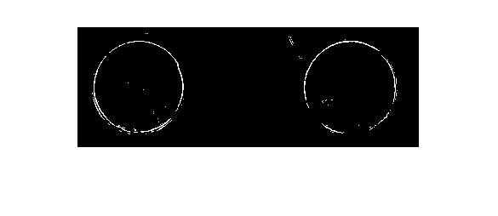

Figure 1: LoG

# 

Figure 2: Canny

Discussions:

The Figure 1 shows edges image using LoG method, which has a laplacian of gaussian operator with size of 7, sigma of 0.2. Also, the threshold value of opposing absolute difference of 3200. It filtered most of the noise, but causes some broken edges, and have difficult to eliminate isolated points.

The Figure 2 shows a clear edge using MATLAB build-in function “edge (image, 'Canny', threshold, sigma); For this picture, one of the effective sigma values is 10;

There are big differences between Figure 1 and 2. Figure 1 can make up the broken edge by decreasing the opposing absolute difference thresholding value, but introduces more noise as an result of isolated points, photo noise, and scratch on the surface. On the other hand, Figure 2 shows the full edge with clean background, because of the non-maxima suppression to thin the ridges.

# Corner Detection

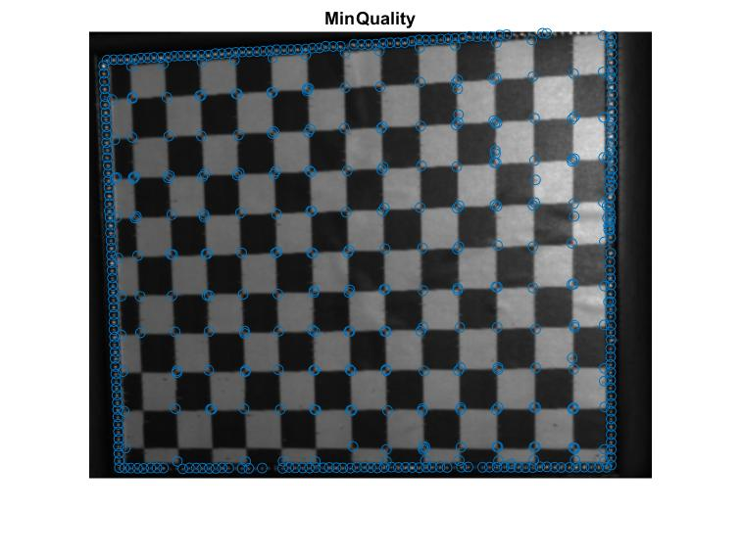

Figure 3: Corner dectection using MInQuality method

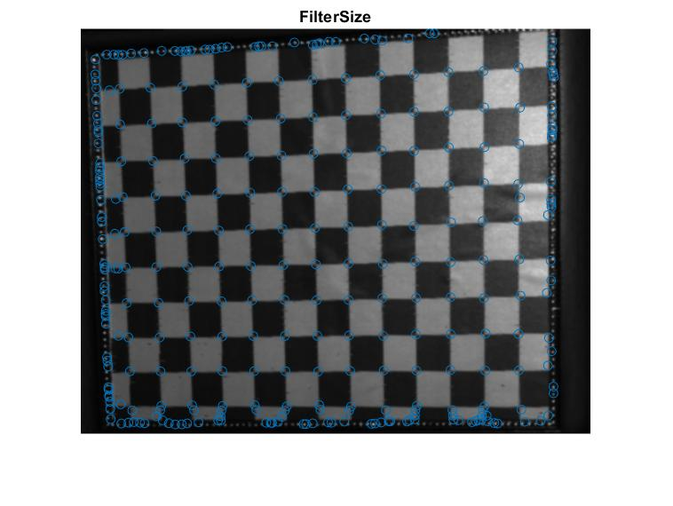

Figure 4: Corner detection using FilterSize method

There are three methods can be used for MATLAB build-in corner detection function: points = detectHarrisFeatures (I, Name, Value); Figure 4 shows the MinQuality method, as Minimum accepted quality of corners set to be 0.005. Figures 5 show the FilterSize method, where filter size set as 23. The first method have more advantage on suppress the noise effect caused by the image boundary.

# Hough Transform

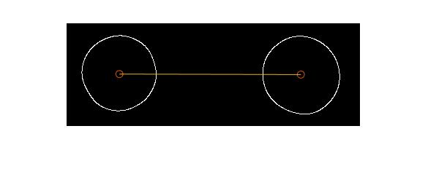

Figure 5: Center detection

The centers and distance are shown above in Figured 5. The image is firstly filtered by a gauss filter, and the extracted by function: CircularHough_Grd [1], with the possible radius range set to be [40 60]. The centers coordinates are [72.6989412279265, 70.2145636529413] and [320.747805989576, 70.9079601387537]. The distance between two circle centers is [248.0488647616491, 0.693396485812443] in vector, and 248.0498339209873 in scaler.

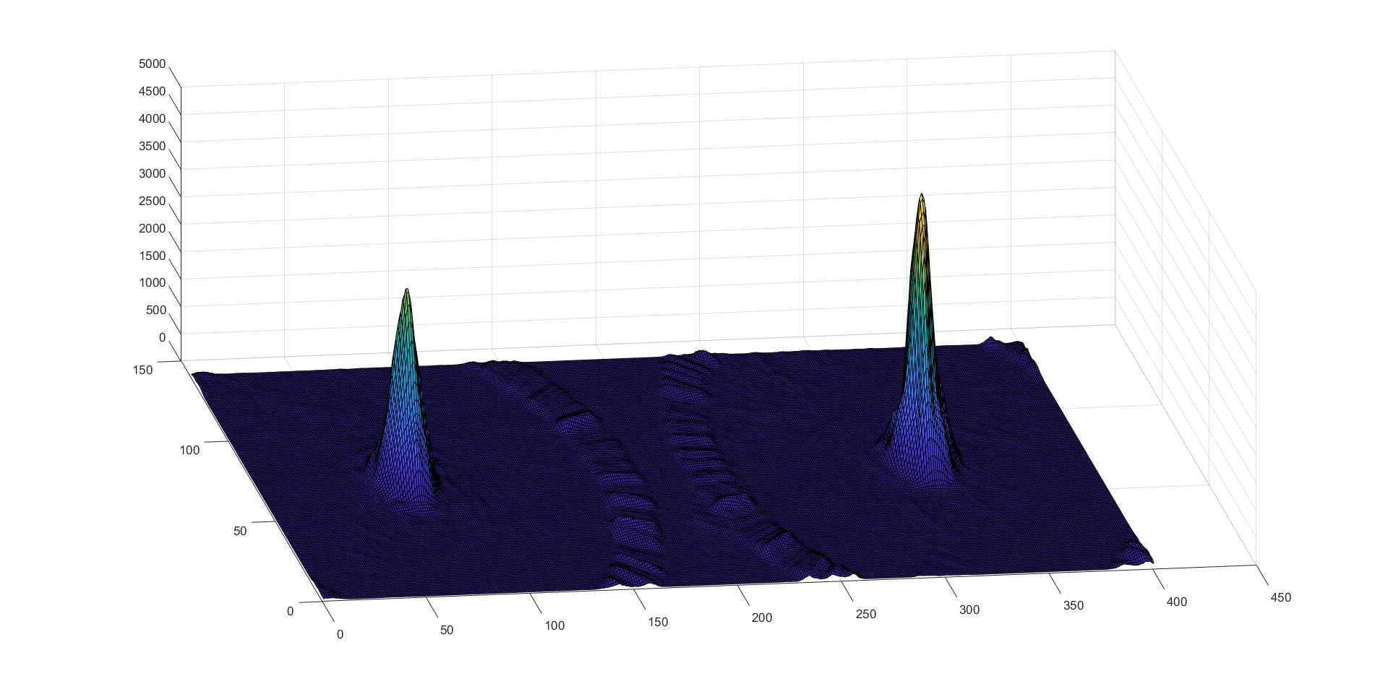

Figure 6: Accumulator

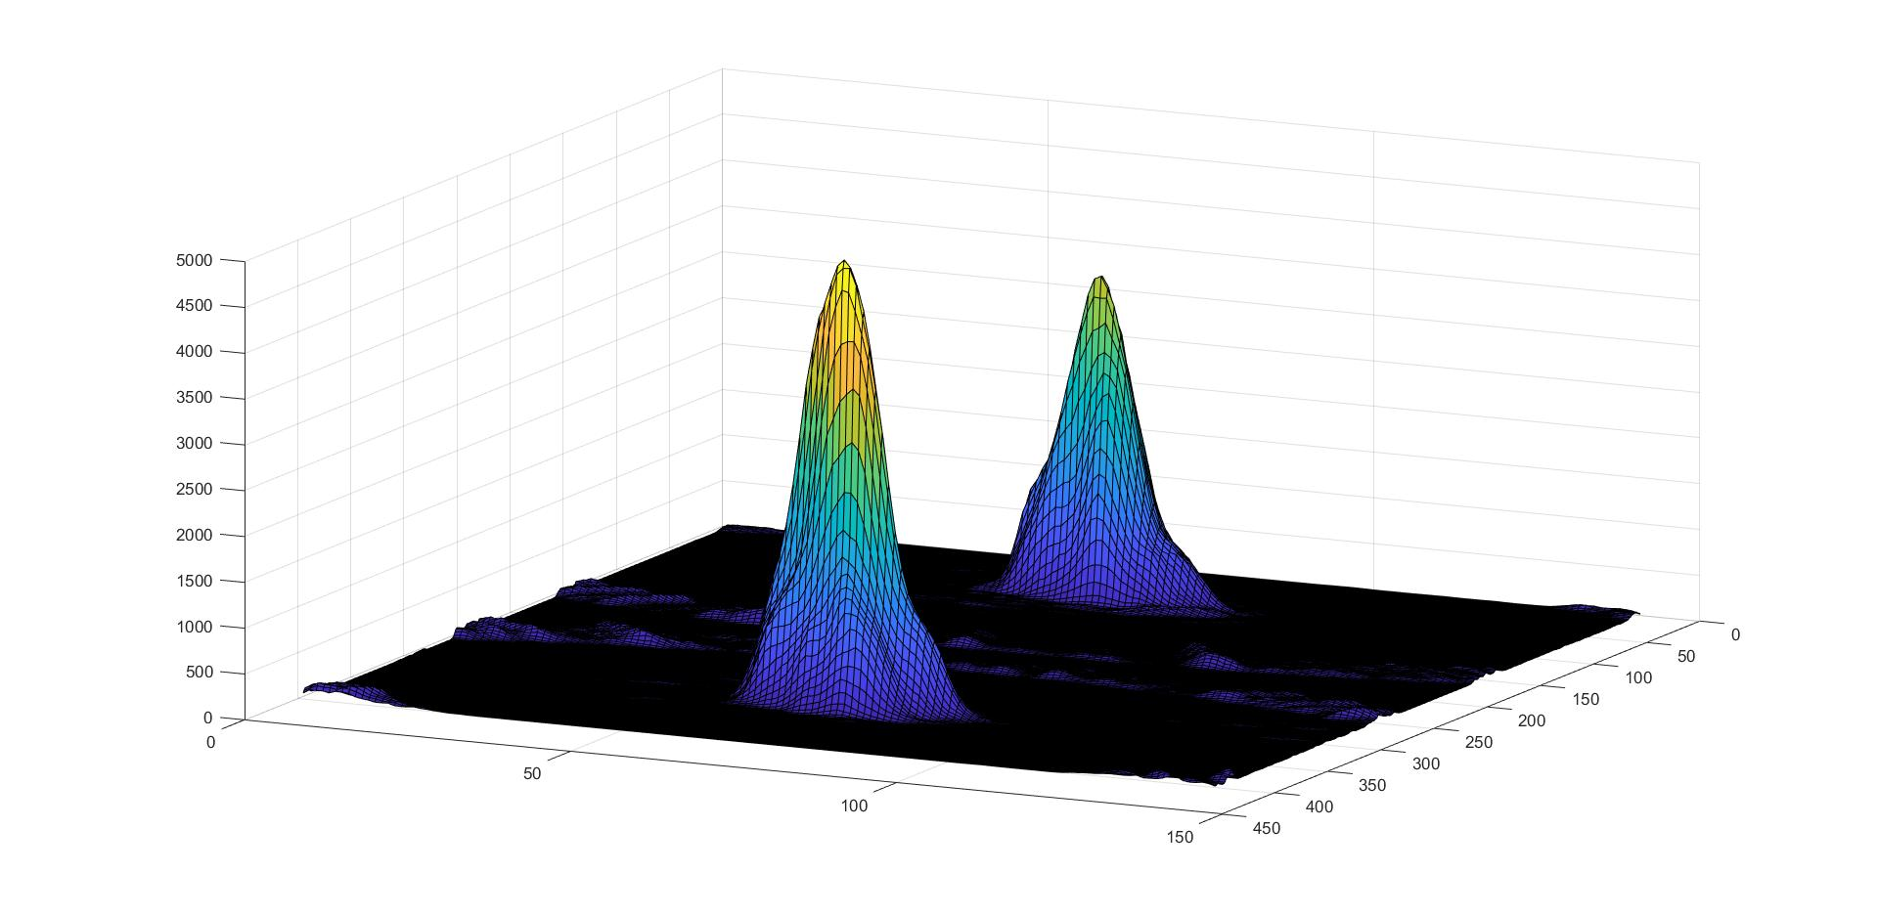

Figure 7: Accumulator

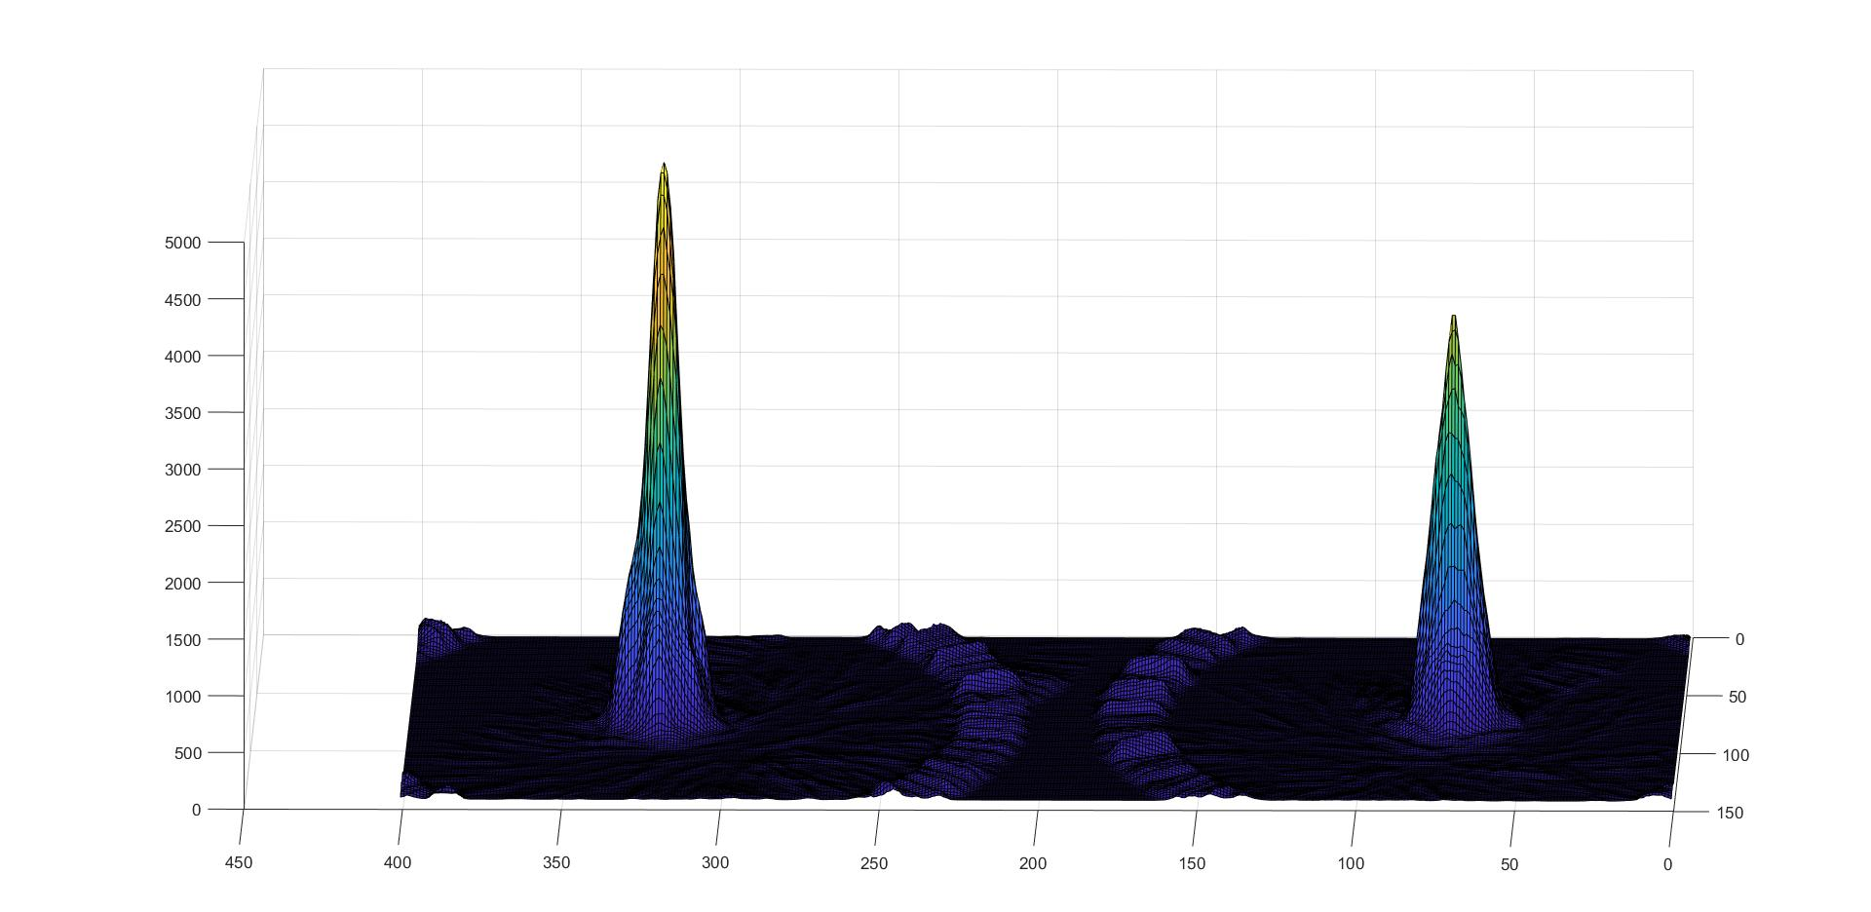

Figure 8: Accumulator

# Sources:

[1] Peng, T. (2017, November 17). Detect circles with various radii in grayscale image via Hough Transform - File Exchange - MATLAB Central. Retrieved March 29, 2019, from <https://www.mathworks.com/matlabcentral/fileexchange/9168-detect-circles-with-various-radii-in-grayscale-image-via-hough-transform>